Utah & Colorado Water Resources
Designing a Modeling User Interface Incorporating Landsat to
Monitor Changes in Riparian Vegetation and Endangered Fish Habitat


Technical Report
Final Draft – August 9th, 2018

Margaret Mulhern (Project Lead)
Daniel Carver
Kristen Dennis
Nathaniel Penrod

Dr. Paul Evangelista, Colorado State University, Natural Resource Ecology Laboratory (Science Advisor)
Dr. Catherine Jarnevich, United States Geological Survey (Science Advisor)
Nicholas Young, Colorado State University, Natural Resource Ecology Laboratory (Science Advisor)
Tony Vorster, Colorado State University, Natural Resource Ecology Laboratory (Science Advisor)
Brian Woodward, Colorado State University, Natural Resource Ecology Laboratory (Science Advisor)

1. Abstract
Since the completion of the Flaming Gorge Dam in 1964, artificial flow releases along the Green River have promoted channel narrowing and encouraged non-native vegetation encroachment into the active stream channel. These changes in the Green River’s flow regime have reduced the backwater habitat of four native endangered fish species: the Colorado pikeminnow (Ptychocheilus lucius), Razorback Sucker (Xyrauchen texanus), Humpback Chub (Gila cypha), and Bonytail (Gila elegans). To promote population recovery, this project developed the River Morphology Evaluation Toolbox (RMET), a Google Earth Engine (GEE) tool, to more efficiently and cost-effectively monitor changes in vegetation and hydrology across large spatial and temporal scales. Using imagery collected from Landsat 5 Thematic Mapper (TM), Landsat 7 Enhanced Thematic Mapper Plus (ETM+), Landsat 8 Operational Land Imager (OLI) and Thermal Infrared Sensor (TIRS), Shuttle Radar Topography Mission (SRTM), and Sentinel-2 Multispectral Instrument (MSI) satellites, the team used the normalized difference vegetation index (NDVI), soil adjusted vegetation index (SAVI), modified normalized difference water index (MNDWI), and normalized difference water index (NDWI) to detect landcover changes. Trends in spectral index changes over user-selected focal years and the magnitudes of those changes were isolated and visualized through RMET. The project partners at the National Park Service and the Upper Colorado River Endangered Fish Recovery Program will use RMET to identify potential sites where changes in riparian vegetation and the active stream channel may have reduced fish habitat to make more informed recommendations for flow releases from the Flaming Gorge Dam.

Keywords
Landsat, Sentinel-2, Colorado Pikeminnow, riparian habitat, Google Earth Engine, Green River, flow releases, Flaming Gorge Dam

2. Introduction

  - Background Information
The rivers of the Upper Colorado River Basin are undergoing dramatic geomorphic changes. The Green River, which flows south from Wyoming through Utah and Colorado, has experienced extreme shifts in flow and sediment regimes due to the construction of the Flaming Gorge Dam (FGD), which was completed in 1964 in northern Utah. These altered regimes have contributed to the reduction of the populations of four endangered native fish species: the Colorado pikeminnow (Ptychocheilus lucius), Razorback Sucker (Xyrauchen txanus), Humpback Chub (Gila cypha), and Bonytail (Gila elegans) (Grams & Schmidt, 2002; “Upper Colorado River Endangered Fish Recovery Program”, 2018). One of the primary factors contributing to population decline was the loss of backwater habitats along main stream channels. Backwater habitats are low to zero flow velocity waters which form behind eddies or gravel bars (Grams & Schmidt, 2002). Because of the low flow velocity, backwaters serve as spawning grounds and nurseries for these endangered species. (Brooks et al., 2000; “Upper Colorado River Endangered Fish Recovery Program”, 2018). In 1988, the Upper Colorado River Endangered Fish Recovery Program (UCREFRP) was formed to help encourage population recovery as a cooperative between federal, state, and private organizations.

Researchers and studies, which have monitored the Green River, have observed lower average peak flows and changes in the size of sediment carried by the river have cut off critical backwater and side channel habitats (Grams & Schmidt, 2002). Since the average flow power of the entire Green River has been reduced, suspended loads, such as fine sands, have become the main sediment type carried by the river. Bed loads carrying courser sand and gravel sediments can only be mobilized during large peak flows which mimic pre-FGD dam 25-year flood events (Grams & Schmidt, 2002). This imbalance between bed and suspended loads has created a shift towards aggrading sandy islands as opposed to active gravel bars (Grams & Schmidt, 2002). As a result, invasive vegetation species have encroached into the active stream channel due to increased soil and nutrient availability along a narrowing fluvial zone (Merritt & Cooper, 2000). These modifications to flow and sediment regimes have reduced stream complexity, encouraged channel narrowing, and promoted vegetation encroachment which are all contributors towards the destruction of backwater habitats. To monitor how these changes have impacted riparian habitat, it was necessary to detect changes in hydrology features and in riparian vegetation distribution over a large area.

The primary area of interest for this study includes the Green River corridor which flows from the FGD into the Colorado River in the southern reaches of Canyonlands National Park (CANY); (Figure 1). The river flows through a semi-arid region of the country with an average precipitation of 8.56 cm (National Park Service, 2016). The study area also included reaches of the Yampa River in Dinosaur National Monument (DINO), the confluence of the White and Green Rivers, and the reach of the Colorado River which flows through CANY.

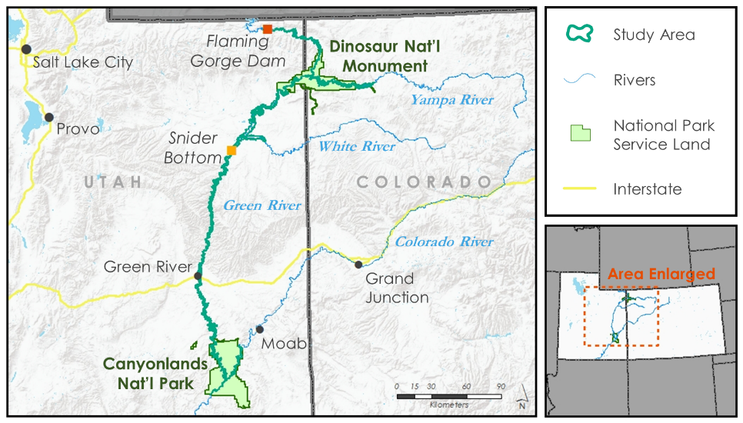
Figure 1: This map depicts the 872 kilometers of riparian corridors within the Upper Colorado River Basin delineating the project study area.
Project Partners & Objectives
For this project, we partnered with the National Park Service (NPS) Water Resources Division, the NPS Inventory & Monitoring Division, Northern Colorado Plateau Network and the UCREFRP. They are interested in studying and qualifying the impacts of the FGD flow release regime on both the river channel and the endangered fish populations. Monitoring efforts have been limited to annual field observations and historic photographs. This has restricted study sites with historical data to a small number of areas. The project partners requested a means by which they could identify temporal and spatial changes of channel forms, riparian vegetation, and sediment features throughout the study area. Having this capability would increase their knowledge of geomorphic changes associated with dam releases downstream of FGD and inform decisions on future field monitoring locations as well as current and future proposed changes to the flow recommendations. Prior to our study, an analysis of this spatial scale was infeasible with field observations alone due to our partner’s time and resource constraints.

To meet this need, our objectives were to: (1) test the feasibility of river geomorphology change and vegetation encroachment detection using NASA Earth observations, (2) create a model which uses vegetation and water spectral indices to create binary maps for change detection analysis, and (3) create a graphic user interface tool within Google Earth Engine (GEE) and accompanying tutorial to meet our partner’s long term management needs.

3. Methodology

3.1 Data Acquisition
We acquired Earth observation data from both NASA and European Space Agency (ESA) sensors (Table 1) using the GEE interface. Additionally, we collected ancillary data from the National Hydrography Dataset Plus High Resolution (NHDPlus HR) dataset from the National Map, National Agricultural Imagery Program (NAIP) from 2015 and 2016 using GEE, and a valley bottom model derived using the Valley Bottom Extraction Tool (V-BET) from the Evangelista Lab at the Natural Resource Ecology Laboratory at Colorado State University (Woodward et al., in press; Gilbert et al., 2016).

Table 1
Earth Observations
Platform & Sensor | Use | Date Range
Landsat 5 Thematic Mapper (TM), Collection 1 Tier 1 Surface Reflectance | This dataset provided the temporal (16 days) and spatial (30 m²) resolution needed for mapping channel narrowing and riparian vegetation encroachment. | Jan 1, 1984 - May 5, 2012
Landsat 7 Enhanced Thematic Mapper Plus (ETM+), Collection 1 Tier 1 Surface Reflectance | This dataset provided the temporal (16 days) and spatial (30 m²) resolution needed for mapping channel narrowing and riparian vegetation encroachment. | Jan 1, 1999 - May 24, 2018
Landsat 8 Operational Land Imager (OLI), Collection 1 Tier 1 Surface Reflectance | This dataset provided the temporal (16 days) and spatial (30 m²) resolution needed for mapping channel narrowing and riparian vegetation encroachment. | Apr 11, 2013 - Jun 14, 2018
Sentinel-2 Multispectral Instrument (MSI), Level-1C | This dataset provided the temporal and spatial (10 m²) resolution needed for mapping backwater habitats. | Jun 23, 2015 - Jun 18, 2018
Shuttle Radar Topography Mission (SRTM) | This dataset was used to derive topographic indices to be used as predictors that could represent important characteristics of hydrologic networks. | 2000

3.2 Data Processing

3.2.1 Creating Study Area Fusion Tables
After acquiring data, the team created Google fusion tables for our overall study area, the reaches of each of the four rivers within our study area, and for the extent of our study area rivers in DINO and CANY. Google fusion tables are a data format which GEE uses to visualize data and can be derived from shapefiles. To create these fusion tables, the team downloaded shapefiles of NHDPlus HR data and V-BET data for the Upper Colorado River Basin and imported them into ArcMap. NHDPlus HR data from six subregions were merged together, and the flowlines for the Colorado, Green, White, and Yampa rivers were extracted into their own shapefile. This shapefile was further clipped down to the area of these rivers which fell within our area of interest. These clipped river extents were overlaid on the V-BET model, and a polygon was digitized around the valley bottoms of the four rivers and small surrounding gullies and valleys. The large V-BET dataset for the Upper Colorado River Basin was clipped to the extent of the digitized polygon. We employed this approach to select the valley bottoms around our four study area rivers because the V-BET data were created as several massive polygons and could not be queried to select out the valley bottoms of specific rivers.

Next, the clipped V-BET layer was buffered by 60 meters to include the width of two Landsat pixels on either side of the model. Taking this step allowed the team to capture areas where the valley bottom was smaller than one Landsat pixel (30 meters) across and conduct our analysis within the confines of valley bottoms and areas immediately beside them which accelerated processing speed. The buffered V-BET shapefile was clipped to the extents of the Colorado, Green, White, and Yampa rivers, and to the extents of these rivers in DINO and CANY to create shapefiles for these six areas of interest. Subsequently, the buffered V-BET shapefiles for our whole study area and for each of the six smaller areas of interest were compressed into individual zipped folders and converted into Google fusion tables using the Fusion Table conversion tool at https://fusiontables.google.com. The seven resulting fusion tables were added into GEE as feature collections to serve as the regions of interest within RMET.

3.2.2 Determining Thresholds for Landcover Classification
The next step in our analysis was to select thresholds to create a landcover classification of vegetation and water (Figures B1, B2). Thresholding spectral indices to produce landcover classifications was a simple approach to quickly identify landcover (Ji et al., 2009). To identify water, our team used the Modified Normalized Difference Water Index (MNDWI) when working with Landsat and the Normalized Difference Water Index (NDWI) when working with Sentinel-2. We used different water indices for these two sensors because the bands needed to calculate MNDWI were only available at a 20 meter resolution for Sentinel-2, and we wanted to preserve the 10 meter resolution which Sentinel-2 can deliver when utilizing the bands in the NDWI equation (Table A1). To identify vegetation, our team used the Normalized Difference Vegetation Index (NDVI) and the Soil Adjusted Vegetation Index (SAVI) across both the Landsat and Sentinel-2 platforms (Table A1). Based on data which we received from our project partners, we used two different methods to determine thresholds to classify landcover

To determine thresholds for MNDWI and NDWI, we employed a two-step approach in GEE. First, we imported USDA National Agriculture Imagery Program (NAIP) 1 meter imagery, which supports ocular digital sampling for known water points. Landsat 8 OLI imagery was also imported and filtered to produce a single median composite image from the same year and month as the NAIP imagery. An MNDWI layer was created using the Landsat 8 OLI image and used as an overlay on the NAIP imagery. Threshold calibration was performed using 20 MNDWI pixel values, which were visually confirmed to include water using the GEE Inspector tool. The median MNDWI value for these 20 Landsat pixels, which overlay known water points sampled from NAIP imagery, was determined to be 0.15. To generate water landcover class maps, we classified all pixels with an MNDWI or NDWI value greater than 0.15 as water and a value less than 0.15 as not water. To determine vegetation thresholds, a more rigorous method utilizing vegetation maps provided by the NPS was employed.

To threshold for vegetation, the team created histograms and statistics for NDVI and SAVI values within digitized polygons created by the NPS to mark areas of known riparian vegetation in both DINO and CANY in 2014. These riparian vegetation polygons were imported into ArcMap. The same filtered and reduced 2014 Landsat 8 OLI imagery described during the MNDWI threshold step was utilized to derive NDVI and SAVI layers, which were further clipped to the boundaries of DINO and CANY. The newly clipped layers were exported from GEE as rasters and imported into ArcMap. In ArcMap, the NDVI and SAVI rasters were clipped to the NPS vegetation polygons using the Extract by Mask tool and converted into points with the Raster to Point tool. This created centroids for all the Landsat pixels which intersected the NPS vegetation polygons and allowed the team to export NDVI and SAVI values which fell within known vegetation areas to Microsoft Excel to construct histograms and run statistics (Figures C1-C4; Table C1).

For the selection of vegetation threshold values, several factors were taken into consideration. First, the project partners requested a tool which would over predict vegetation, to identify the initial stages of vegetation encroachment. To meet this need, NDVI and SAVI thresholds needed to classify mixed pixels which may only be partially covered with vegetation or sparsely vegetated with small herbaceous growth as vegetation. Second, we considered the precision of the NPS vegetation polygons. For instance, the DINO polygon dataset contained noticeable errors, while the CANY polygon data appeared to be more accurate. The CANY polygons were edited from 2002 linework to closely fit over the top of NAIP imagery from 2014. Taking these two factors into account, our team chose thresholds by subtracting one standard deviation from the median value of the spectral index (Table 2). Interestingly, the SAVI thresholds for both DINO and CANY matched, but the NDVI thresholds for DINO and CANY differed by 0.04. Since the CANY vegetation polygons appeared to be more accurate, we opted to use the 0.17 threshold instead of the 0.13 threshold. To account for landscape variability across the 872 kilometers of our study area, our team recommend 0.17 as a threshold for NDVI and 0.21 as a threshold for SAVI with the option for the end user to adjust the thresholds within the RMET Graphical User Interface (GUI).

Table 2
Vegetation Landcover Classification Thresholds
 | NDVI | SAVI
Dinosaur National Monument | 0.13 | 0.21
Canyonlands National Park | 0.17 | 0.21

3.2.3 Processing imagery in RMET
After determining thresholds, imagery was processed for analysis in GEE within the RMET script. To serve as the baseline for the RMET script, we adapted several functions from the SAVeTrEE script available on the NASA DEVELOP GitHub (Lassen Volcanic National Park Disasters (I, II), 2017). RMET consists of multiple functions built on smaller functions running in succession, allowing users to choose and process imagery to create a single composite image. The composite image was utilized to create spectral indices maps for the end user to analyze and employ as a tool. Within RMET, the end user selected an area of interest from a drop-down menu. This selection was run through an if/else statement, which finds the fusion table storing the geometric location and attribute information of the selected region. This function allowed end users to restrict the imagery and maps to designated areas. Next, the years of interest were defined. The end user inputted year(s) of interest in YYYY format. Those values were assigned to variables within the RMET script. The functions for computing NDVI, MNDWI, NDWI, and SAVI from Landsat 5, 7, 8 and Sentinel-2 imagery were defined. Two dictionaries were created, one for Landsat 5, 7, and 8; and one for Sentinel-2. The dictionaries stored one image for each year, which were filtered by the months April - September, area of interest, cloud cover less than 30%, and reduced using a median reducer. These parameters allowed RMET to capture median values for spectral indices during the season which contains both peak river flow and peak vegetation. By employing the median reducer, outliers were removed from the images. Finally, the user defined years were pulled from the dictionaries. The median composite image stored for each of the years was clipped to the study area. Then the indices NDVI, MNDWI, NDWI, and SAVI were computed and added as bands to the processed image. At the culmination of the processed functions in RMET, the end user received a composite processed image to further explore through the end user’s directed mapping investigations.

3.2.4 Creating Binary Landcover Classification Maps in RMET
The landcover classification model was the first model developed in RMET. To generate maps from this model, binary vegetation and binary water maps were created using processed Earth observation imagery. The bands containing either the vegetation or water spectral index of interest were selected and the respective classification threshold was applied to create a binary presence/absence map for a landcover class. The suggested thresholds act as a default value; however, RMET allows users to test a variety of threshold values by adjusting the provided slider bar. The ability to change threshold variables was important, as it allows the thresholds to be adapted for different landscapes. The binary classification maps display values of 1, which represent the presence of vegetation (NDVI or SAVI) or water (MNDWI or NDWI), and values of 0 represent the absence of the respective landcover types. Once those presence/absence values were assigned, the script applies a mask to the zero values. From these steps, landcover classification maps for vegetation and water were generated and viewed in RMET.

3.2.5 Creating Spectral Indices Change Maps in RMET
The second model built into RMET created spectral indices change maps, which used the differences in the respective spectral index values between two defined years to determine the location, magnitude, and trend of change. Since the model only compared values between two years, it was sensitive to variations caused by high spring runoff, floods, or droughts. Knowledge of yearly river discharge rates were essential to avoid differencing a wet year from a drought year, which exaggerated the actual changes on the ground. In RMET we suggested comparing wet, dry, and average years to similar typed years to avoid amplifying change trends.
Once a start and end year were selected, RMET used the NDVI and MNDWI bands of processed Landsat images and the NDVI and NDWI bands of processed Sentinel-2 images. Values of the spectral index in the start year were subtracted from the values of the same spectral index in the end year. From these differences, change trends were isolated using binary maps. To determine where spectral index values increased, a binary map was created where pixels trend towards a spectral index value of 1 over the time frame were denoted as the binary 1, and pixels which trended towards a -1 value over the time frame were denoted as the binary 0. Conversely, to determine where spectral index values decreased, a binary map was created where pixels which trended closer to -1 over the allotted time frame were denoted as a 1, and pixels which moved towards 1 over the time frame were denoted as 0. The trend rasters were multiplied by the magnitude of change rasters to show magnitude of change for green and less green trends derived from NDVI differences, and wet and dry trends derived from MNDWI and NDWI differences.

3.2.6 Generating Spectral Indices Change Charts in RMET
The final tool incorporated into RMET was the spectral index change charts. While the spectral indices difference model compared changes between two times, these charts allowed a user to identify how the value of NDVI has changed from year to year in a user-selected Landsat pixel. The values used to create these charts were derived using LandTrendr, which was an open source code adapted for making composite images from time series data for trend analysis (Kennedy et al., 2018). LandTrendr was programmed to calibrate between Landsat 5, Landsat 7, and Landsat 8. This provided the opportunity to determine the greenest pixel for a point for each year, between April and September, in our study period. These values were stored in a time series image collection. This collection was plotted using the chart widget command in Google Earth Engine.

3.3 Case Study Area Data Analysis

To evaluate the performance of the derived thresholds, rasters of NDVI and MDNWI in 2014 for a case study area (Figure 2) were exported from GEE and brought into ArcMap. Subsequently, the landcover classification performed in RMET was mirrored in ArcMap by creating binary rasters which showed landcover classes. To create binary vegetation and water raster, the Raster Calculator tool was used selecting all NDVI values greater than 0.17 and all MNDWI values greater than 0.15. The resulting rasters from this step were reclassified using the Reclassify tool and the pixels with binary values of 1 were assigned to every pixel where NDVI was greater than 0.17 and to every pixel where MNDWI was greater than 0.15. With these binary rasters, we had classified the extent of vegetation and water landcover for our study area for 2014.

The next step was to overlay our vegetation landcover class with the NPS vegetation polygons for CANY in 2014 to evaluate how our landcover classification performed. Since we did not have polygons outlining the active stream channel in 2014, we were not able to validate the performance of our MNDWI threshold for identifying water. However, after overlaying our vegetation landcover class with the NPS polygon, we copied values from the attribute tables of both the vegetation landcover raster into Microsoft Excel. The percentage for which our landcover classification underpredicted and over predicted the presence of vegetation was calculated, as well as the percentage of area which our landcover class overlapped and did not overlap the NPS polygons. Taking this step allowed us to incorporate partner data and support our threshold selection process.

4. Results & Discussion
4.1 Analysis of Results

4.1.1 Case Study Area
The team conducted a case study of RMET functionality on a section of the Green River in the northwestern area of CANY (Figure 2).

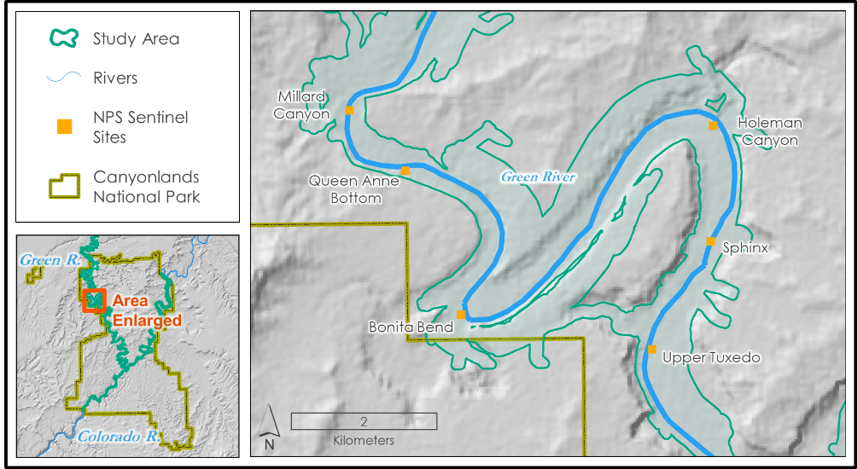
Figure 2: Case study area map depicting the analysis area within Canyonlands National Park.

This area was selected as it contained six monitoring sites, called Sentinel Sites, where our project partners at the NPS regularly conduct field work. Additionally, the NPS had polygons of the extent of riparian vegetation in CANY from 1938 through 2014. Selecting an area of the river with which our partners were familiar and had detailed data allowed us to take initial steps to evaluate the performance of our models.

4.1.2 Landcover Classification Model Performance
The primary uses of our landcover classification model was to quantify and visualize how the amount of area covered by vegetation and water has changed. Below are two maps we generated for two years which represented average river discharge rates (Figure 3). Using 30 meter Landsat pixel in our case study area, we observed a 25% increase in vegetated areas and a 26% decrease in wetted areas (Figure 4).

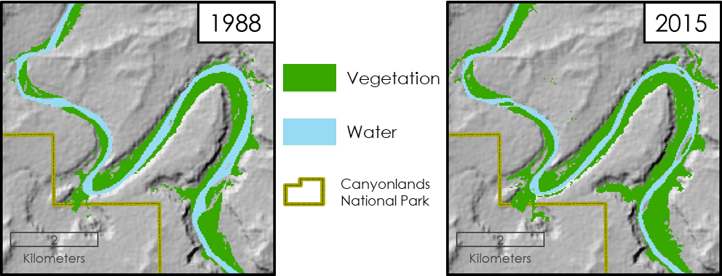
Figure 3: Landcover classification based off NDVI and MNDWI threshold for 1988 and 2015 in the case study area.

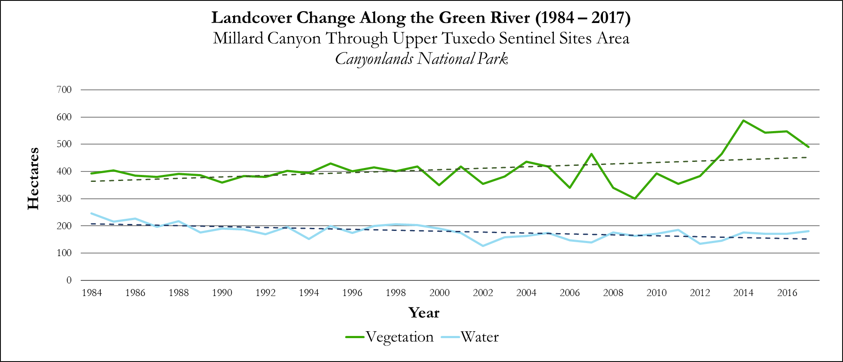
Figure 4: Area of vegetation and water change between 1984 and 2017 in the case study area.

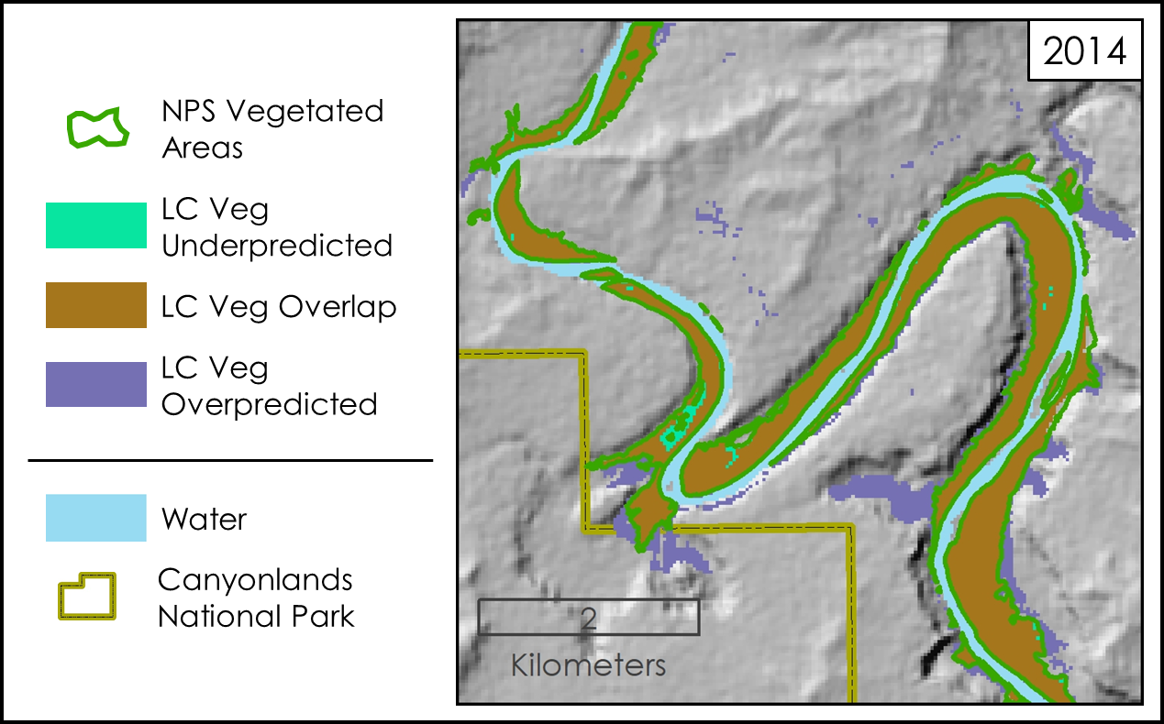
However, while the water landcover maps showed a narrower and less complex stream channel over time, some of the differences in area and distribution were small due to a much more gradual decrease in the overall wetted area. We compared the landcover classification for vegetation in 2014 to digitized riparian vegetation polygons for CANY in 2014 from our partners at the NPS (Figure 5). The accurate classification of vegetation was essential to RMET because our partners wanted the ability to identify all areas where vegetation might have been each year. We found with our empirically derived threshold of 0.17 for NDVI in this case study area, did not classify areas marked as vegetation by the NPS only 6% of the time, and predicted an additional 33% more vegetated area within the confines of V-BET than the NPS data. Our landcover classification model for 2014 overlapped 414.8 hectares of the 443.5 hectares mapped as vegetation by the NPS in our case study area (Table D1). This relatively high coincidence provided us with confidence in this model for the CANY case study region.
Figure 5: This map compares RMET’s landcover classification model to NPS vegetation data for 2014. “LC” in the legend stands for landcover.

4.1.3 Spectral Indices Difference Model
The model allowed the end user to quickly analyze the location with the most likely change in landcover type between two years and potentially identify where backwater habitats have been lost. This is valuable for our partners because it will allow them to quickly look at stretches of river and see where the largest changes have occurred, outlining potential field survey locations. For our case study area, we subtracted the values of NDVI and MNDWI in 1988 from NDVI and MNDWI values in 2015 respectively, to gain an idea of where the most change occurred in our case study area (Figure 6; Figures E1, E2) From the analysis, the difference in NDVI values showed 82% of pixels in the study area were greener, meaning there was likely vegetation growth in the area. The difference in MNDWI values showed 87% of pixels in the study area became drier, therefore, these pixels likely did not contain as much water in 2015 as they did in 1988.

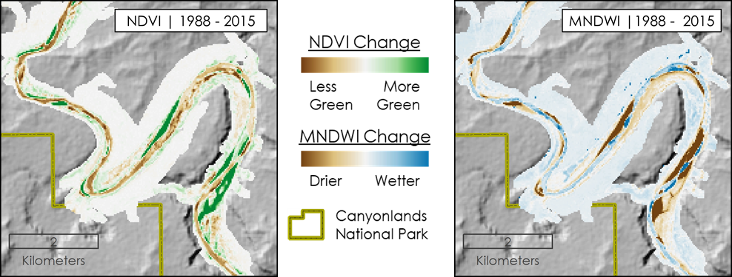
Figure 6: Maps of the difference of NDVI and MNDWI values between 2015 and 1988. The darker colors highlight areas where a landcover change may have taken place.

4.1.4 Spectral Index Change Charts
The final outputs of RMET were spectral index change charts, which were designed to complement the spectral index difference maps and give the user a graphical read-out of how spectral index values have changed from year to year instead of just between two years. These charts were generated for a point the end user clicks. In this case study, we generated a chart for the Landsat pixel which intersects the Upper Tuxedo NPS Sentinel monitoring site (Figure 2). However, it was important to note, this chart was derived from median reduced Landsat images because the LandTrendr code, which allows the user to isolate the greenest value for a pixel, was not operational when we were generating our case study results. The chart derived from median reduced images does, however, show a remarkable picture of changes, which have occurred over the past 33 years in this 900 m² patch of ground (Figure 7). From 1984 to 2001, the chart demonstrates the classification of water for this pixel, according to our recommended thresholds. However, from 2001 to 2012 a change took place where the pixel underwent a transition towards being classified as vegetation. From 2012 to 2017; this pixel became classified as vegetation, using our recommended vegetation threshold, which indicated the pixel was once part of the active stream channel, but has become vegetated.

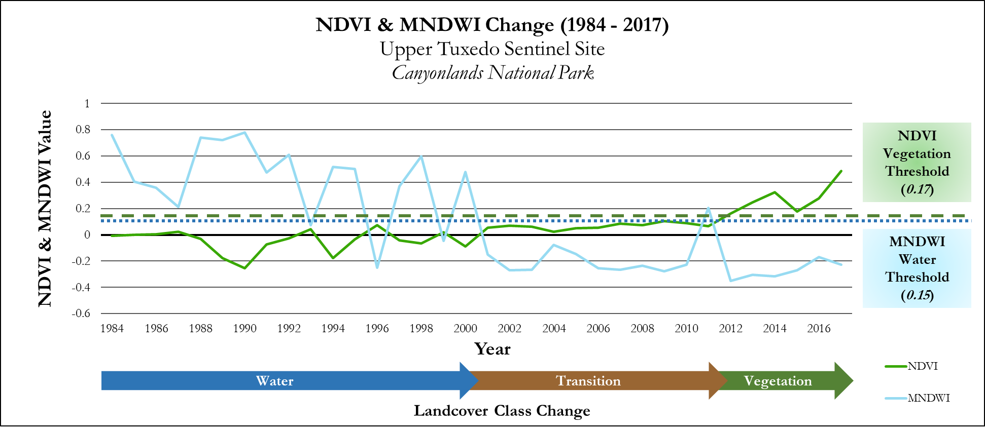
Figure 7: This chart shows the values of NDVI and MNDWI at the Upper Tuxedo Sentinel Site from 1984 to 2017. This graph can be used to illustrate the magnitude of change, identify wet and dry years, and track landcover change.

4.1.4 The RMET GUI
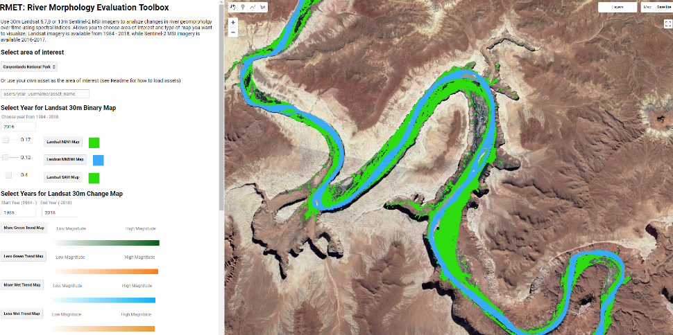
The RMET GUI combines the power of GEE cloud computing, storage and simple analysis techniques to help our project partners quickly scale their analysis and work with Earth observation data. The tool allowed the user to change different analysis parameters, such as the study area, analysis years, and spectral indices thresholds to help answer a variety of river morphology questions. (Figure 8).
Figure 8: This is a screen capture of the RMET GUI for GEE. Displayed in it is the landcover classification model output for 2016.

4.2 Caveats and Data Limitations
This project had several caveats and limitations. Most importantly, RMET can only function to its highest value if the user has a priori knowledge about the study area. Specifically, the knowledge of ‘wet’, ‘dry’ and ‘average’ years were of utmost importance. Without this knowledge, differences seen in a spectral index over a range of time may be miss-interpreted. Additionally, at the 30 meter Landsat resolution more mixed pixels along the edge of the river were neither classified as presence in both the vegetation binary map nor the water binary map. This limits the ability to quantify changes in riparian vegetation. The 30 meter resolution of the Landsat section of RMET was useful in detecting larger changes in river morphology; however, it potentially misses changes in smaller side channels and backwater habitats. To address this, a 10 meter Sentinel-2 section was made available in RMET. Employing Sentinel-2 as the focal sensors results in lower temporal resolution but improved spatial resolution. This makes the Sentinel-2 maps more informative for management efforts for current and future monitoring, while being insufficient for investigations into the past. The study area perimeters were determined by the V-BET model. We recognize there were areas where the river and riparian areas were cut off due to the 30 meter resolution of the DEM used to create the model. Due to the study area stretching over 872 km of river, it was not feasible to manually fix areas of cut off river system. Finally, the spectral indices difference model was not used to classify change but showed where change has occurred.

4.3 Future Work
There are opportunities for improvement of both the RMET GUI and its analysis tools. The RMET code should be revised to automatically update the image collections of both the Landsat and Sentinel satellites through the most recent year. This would reduce the future maintenance needed to the RMET code. Also, incorporating Light Detection And Ranging (LiDAR) data holds tremendous promise. LiDAR maps features on the Earth’s surface at an incredibly fine scale, and the point cloud LiDAR data could be used to differentiate between shrub and tree vegetation types. Furthermore, LiDAR could significantly increase the accuracy of the valley bottom model derived from V-BET data which was used to construct the study area for this project. If a new valley bottom layer was created from LiDAR, it would reduce the number of areas of the stream which were cut off by the current V-BET model due to steep canyon walls and a large spatial resolution of elevation data used to create it. Finally, LiDAR could be utilized to map fine-scale channel measurements, including the distribution of backwater habitats instead of just landcover changes in riparian zones. While these are just a few improvement opportunities, incorporating them in future research would most likely improve the usefulness of RMET for our project partners.

5. Conclusions
This project produced RMET to be used for investigating changes in river morphology between a wide range of years at a 30 meter resolution and recent years at a 10 meter resolution. RMET will aid our partners at the NPS and UCREFRP in their monitoring efforts and potentialy identify locations of critical habitat loss for endangered fish. Through a case study in CANY, we demonstrated the toolbox provides quick and relevant mapping. These findings are consistent with vegetation encroachment and channel narrowing, which suggests endangered fish habitat has been reduced in this region. Using these maps to identify where large spectral index changes occurred will be a powerful tool for our partners going forward to quickly identify areas where landcover, and consequently habitats and ecosystems, have changed over time. While it was a simple tool, by making these three analysis tools interactive through a GUI in GEE, this project not only built the capacity of our project partners to use NASA and ESA Earth observations, but provided them with an adaptable analysis toolbox, enabling them to rapidly scale their monitoring efforts to support endangered fish habitat recovery and study the impacts of environmental flow releases from the Flaming Gorge Dam on riparian ecosystems.

6. Acknowledgments
The Utah & Colorado Water Resources team is grateful for the guidance and collaboration received from their team of science advisors:
- Dr. Paul Evangelista (Colorado State University, Natural Resource Ecology Laboratory)
- Dr. Catherine Jarnevich (United States Geological Survey)
- Nicholas Young (Colorado State University, Natural Resource Ecology Laboratory)
- Tony Vorster (Colorado State University, Natural Resource Ecology Laboratory)
- Brian Woodward (Colorado State University, Natural Resource Ecology Laboratory)

Additionally, the team appreciates the cooperation, enthusiasm, and assistance of the Utah & Colorado Water Resources project partners, who made this project possible:
- Melissa Trammell (National Park Service, Water Resources Division)
- Dusty Perkins (National Park Service, Inventory & Monitoring Division)
- Don Anderson (Upper Colorado River Endangered Fish Recovery Program)
This material contains modified Copernicus Sentinel data (2015-2017), processed by ESA.

Any opinions, findings, and conclusions or recommendations expressed in this material are those of the author(s) and do not necessarily reflect the views of the National Aeronautics and Space Administration.

This material is based upon work supported by NASA through contract NNL16AA05C and cooperative agreement NNX14AB60A

7. Glossary
Backwaters - “. . . areas of stagnant or low-velocity flow that occur behind emergent eddy sand bars at low flow” (Grams & Schmidt, 2002).
Bed Load - Sediment particles that are transported along the bed of a river, generally of coarser size
CANY - Acronym for Canyonlands National Park
Confluence - The junction of two rivers
DINO - Acronym for Dinosaur National Monument
Earth observations – Satellites and sensors that collect information about the Earth’s physical, chemical, and biological systems over space and time
ESA - European Space Agency
FGD - Acronym for Flaming Gorge Dam in northern Utah
Fluvial Zone - Area of fluvial activity including the perennially active stream channel, ephemeral stream channel, and active floodplains
GGE - Acronym for Google Earth Engine
MNDWI - Modified Normalized Difference Water Index
NAIP - National Agricultural Imagery Program
NDVI - Normalized Difference Vegetation Index
NDWI - Normalized Difference Water Index
NHDPlusHR - National Hydrography Dataset Plus High Resolution
Riparian zone - Area immediately surrounding a river or stream
SAVI - Soil Adjusted Vegetation Index
Suspended Load - Sediment particles that are transported with a river by suspension, generally of a finer size
UCREFRP - Acronym for Upper Colorado River Endangered Fish Recovery Program
V-BET - Valley Bottom Extraction Tool

8. References
Brooks, J. E., Buntjer, M. J., & Smith, J. R. (2000). Non-native species interactions: Management implications to aid in recovery of the Colorado pikeminnow Ptychocheilus lucius and Razorback Sucker Xyrauchen texanus in the San Juan River, CO-NM-UT. US Fish & Wildlife Publications. 182. http://digitalcommons.unl.edu/usfwspubs/182

Esri, USGS, NOAA, DeLorme, NPS. (2016). Terrain with labels [Data set]. Esri. https://www.arcgis.com/home/item.html?id=fe44cf9a739848939988addfeba473e4

Grams, P. E. & Schmidt, J. C. (2002). Streamflow regulation and multi-level flood plain formation: channel narrowing on the aggrading Green River in the eastern Uinta Mountains, Colorado and Utah. Geomorphology, 44(3–4), 337–360. https://doi.org/10.1016/S0169-555X(01)00182-9

Gilbert, J. T., Macfarlane, W. W., & Wheaton, J. M. (2016). The Valley Bottom Extraction Tool (V-BET): A GIS tool for delineating valley bottoms across entire drainage networks. Computers & Geosciences, 97, 1–14. https://doi.org/10.1016/j.cageo.2016.07.014
Ji, L., Zhang, L., & Wylie, B. (2009). Analysis of dynamic thresholds for the normalized difference water index. Photogrammetric Engineering & Remote Sensing, 75(11), 1307–1317. https://doi.org/10.14358/PERS.75.11.1307

Kennedy, R.E., Yang, Z., Gorelick, N., Braaten, J., Cavalcante, L., Cohen, W.B., Healey, S. (2018). Implementation of the LandTrendr Algorithm on Google Earth Engine. Remote Sensing. 10(5), 691. https://doi.org/10.3390/rs10050691

McGarrigle, A., Ferrer, A., Myers, H., Norton, P. (2017) Evaluating Fuel Loading at a Landscape Scale in High Elevation Alpine Forests of Lassen Volcanic National Park. Lassen Volcanic National Park Disasters II. NASA DEVELOP Fall 2017 Term.

Merritt, D. M., & Cooper, D. J. (2000). Riparian vegetation and channel change in response to river regulation: a comparative study of regulated and unregulated streams in the Green River Basin, USA. Regulated Rivers: Research & Management, 16(6), 543–564. https://doi.org/10.1002/1099-1646(200011/12)16:6<543::AID-RRR590>3.0.CO;2-N

NASA JPL (2013). NASA Shuttle Radar Topography Mission Global 1 arc second [Data set]. NASA EOSDIS Land Processes DAAC. doi: 10.5067/MEaSUREs/SRTM/SRTMGL1.003

National Park Service (2016, November 10). Weather. Retrieved June 27, 2018, from
https://www.nps.gov/cany/planyourvisit/weather.htm

Tyus H. M. & McAda, C. W. (1984). Migration, Movements and Habitat Preferences of Colorado Squawfish, Ptychocheilus lucius, in the Green, White and Yampa Rivers, Colorado and Utah. The Southwestern Naturalist, 29(3), 289-299. DOI: 10.2307/3671360

Upper Colorado River Endangered Fish Recovery Program (2018). Retreived June 26, 2018, from http://www.coloradoriverrecovery.org/general-information/about.html

U.S. Geological Survey Earth Resources Observation and Science Center. (2012). Landsat ETM+ Level-2 Surface Reflectance (SR) Science Product [Data set]. U.S. Geological Survey. https://doi.org/10.5066/f7q52mnk

U.S. Geological Survey Earth Resources Observation and Science Center. (2012). Landsat TM Level-2 Surface Reflectance (SR) Science Product [Data set]. U.S. Geological Survey. https://doi.org/10.5066/f7kd1vz9

U.S. Geological Survey Earth Resources Observation and Science Center. (2014). Landsat OLI Level-2 Surface Reflectance (SR) Science Product [Data set]. U.S. Geological Survey. https://doi.org/10.5066/f78s4mzj

U.S. Geological Survey. (2017). National Hydrography Dataset Plus High Resolution (NHDPlus HR) Best Resoultion for HU4-1401, 1403-07 (Subregions) [Data set]. U.S. Geological Survey. https://www.sciencebase.gov/catalog/item/57645ff2e4b07657d19ba8e8

Verkerke, J., McGarrigle, A., Dilger, J. (2017). Utilizing NASA Earth Observations to Better Understand Fuel Loading in High Elevation Alpine Forest in Response to Potential Wildfire Occurrence. Lassen Volcanic National Park Disasters I. NASA DEVELOP Summer 2017 term.

Woodward, B.D., Evangelista, P.H., Young, N.E., Vorster, A.G., West, A., Carroll, S., Girma, R., Hatcher, E., Anderson, R., Vahsen, M., Vashisht, A., Mayer, T., Carver, D., & Jarnevich, C. (in press). Creation of CO-RIP: a riparian vegetation and corridor extent dataset for Colorado River Basin streams and rivers. International Journal of Geo-Information, 7, x. doi: FOR PEER REVIEW

9. Appendices
Appendix A

Equations used to calculate the spectral indices used in this study

Table A1
Spectral Index Equations
Spectral Index | Formula
Normalized Difference Vegetation Index (NDVI) | (NIR - RED) / (NIR + RED)
Modified Normalized Difference Water Index (MNDWI) | (GREEN - SWIR1) / (GREEN + SWIR1)
Soil Adjusted Vegetation Index (SAVI) | ((NIR-RED) / (NIR + RED +0.5)) (1.5)
Normalized Difference Water Index (NDWI) | (GREEN-NIR) / (GREEN + NIR)

Appendix B

Flow charts for general methods and for landcover classification threshold selection

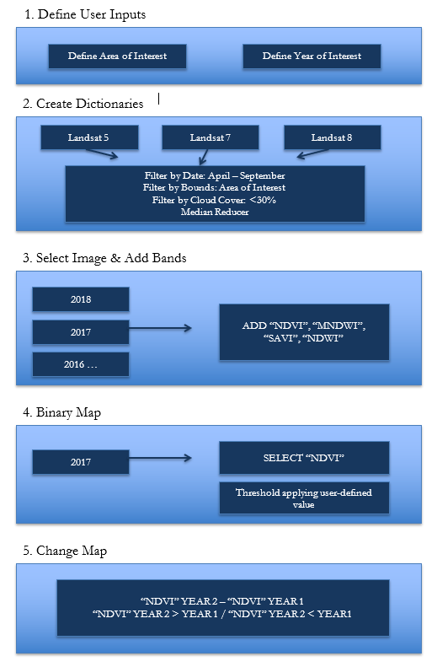
Figure B1: This flowchart depicts the general methods this project used for Methodology sections 3.2.2 through 3.2.5.
This chart shows NDVI

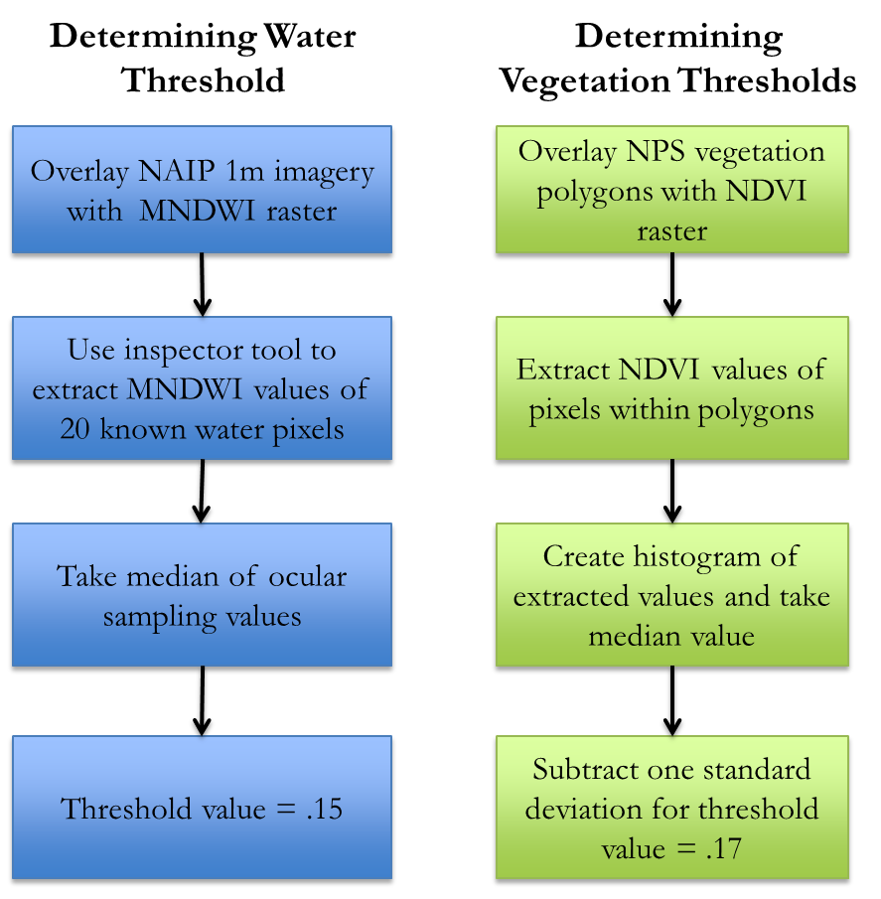

Figure B2: This flowchart depicts the methods used to select water and vegetation thresholds described in Methodology sections 3.2.2
This chart shows NDVI

Appendix C

Histograms and descriptive statistics for NDVI and SAVI values within NPS vegetation polygons in Dinosaur National Monument and Canyonlands National Park for 2014

Figure C1: This histogram represents NDVI values extracted from Landsat 8 cells which fell within previously mapped vegetation areas along the Green and Yampa Rivers in Dinosaur National Monument.
This chart shows NDVI

Figure C2: This histogram represents SAVI values extracted from Landsat 8 cells which fell within previously mapped vegetation areas along the Green and Yampa Rivers in Dinosaur National Monument.
This chart shows NDVI

Figure C3: This histogram represents NDVI values extracted from Landsat 8 cells which fell within previously mapped vegetation areas along the Green and Colorado Rivers in Canyonlands National Park.
This chart shows NDVI

Figure C4: This histogram represents SAVI values extracted from Landsat 8 cells which fell within previously mapped vegetation areas along the Green and Colorado Rivers in Canyonlands National Park.
This chart shows NDVI

Table C1
NDVI and SAVI Statistics Within NPS Mapped Vegetation Areas

 | DINO NDVI | CANY NDVI | DINO SAVI | CANY SAVI
Mean | 0.388 | 0.366 | 0.509 | 0.523
Median | 0.341 | 0.346 | 0.511 | 0.486
Mode | 0.31 | 0.25 | 0.43 | 0.37
Standard Deviation | 0.206 | 0.176 | 0.304 | 0.278
Minimum | -0.744 | -0.202 | -1.017 | -0.279
Maximum | 0.851 | 0.825 | 1.276 | 1.237

Appendix D

Table showing the areas of the vegetation landcover class derived from NDVI in 2014 overlaid with NPS 2014 vegetation polygons in the case study area

Table D1
Vegetation Landcover Classification (LC) Compared with NPS Vegetation Data

Vegetation Landcover Classification (LC) Compared with NPS Vegetation Data | Area (ha)
NPS Vegetation Polygons | 443.5
Vegetation Landcover | 587.43
LC Overlap | 414.8
LC Overpredicted | 147.6
LC Underpredicted | 25.0

Appendix E

NDVI and MNDWI maps used to create the spectral indices change maps from 1988 to 2015 in the case study area

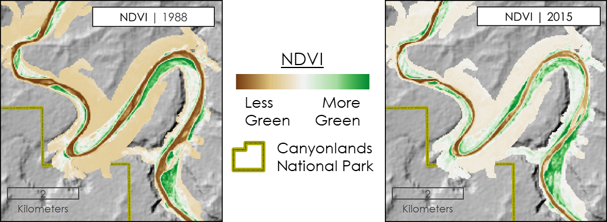
Figure D1: These maps show NDVI values in 1988 and 2015 for our case study area. Visual analysis seems to show that the presence of vegetation increased between 1988 and 2015.
This chart shows NDVI

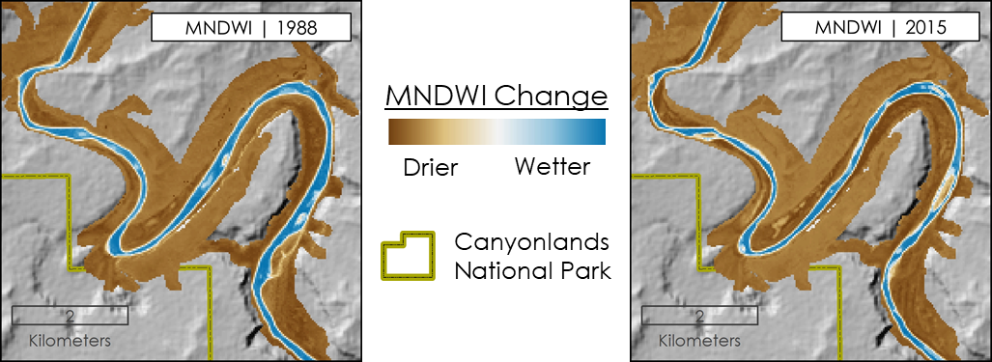
Figure D2: These maps show MNDWI values in 1988 and 2015 for our case study area. Visual analysis seems to show that the river channel width shrunk between 1988 and 2015.
This chart shows NDVI

